# INTRODUCTION

In 2020 Career Training Institute Pty Ltd is again using two systems to manage payroll:

* **Knack** to collect timesheets
* **Employment Hero** to manage timesheet verification and process payroll.

Work placement supervisors will need to login to **Employment Hero** to verify hours worked by students (these are fed in from **Knack**).

CTI will process the payroll on the 15th of each month for CAP students. For ease of processing and consistent pay for students CTI, is now processing the pay on a salary basis. This has been worked so students should get the same net pay each month, instead of having to wait for timesheets to be submitted and approved. However periodical checks will be made to ensure students are completing the expected hours of work and that is why the timesheets still require verification.

# SYSTEM SETUP

Host employer supervisor details are set up on CTI’s Employment Hero account. This provides them access to view and approve the hours the students have submitted as being worked.

**IMPORTANT**: Please do not attempt to set up a login yourself for approving CTI hours. This creates confusion as self-created logins are not linked to our account and so we don’t see copies of the timesheets.

# PORTAL ACCESS & LOGIN – NEW SUPERVISORS

Persons who have not previously been issued a login will receive an email from Employment Hero with a one-time link to set up a password so they can access the system for approving timesheets. If you don’t receive the email from Employment Hero before 10/02/2020 please contact [cap@careertraining.edu.au](mailto:cap@careertraining.edu.au).

### To login:

1. Navigate to login page at: <https://employmenthero.yourpayroll.com.au>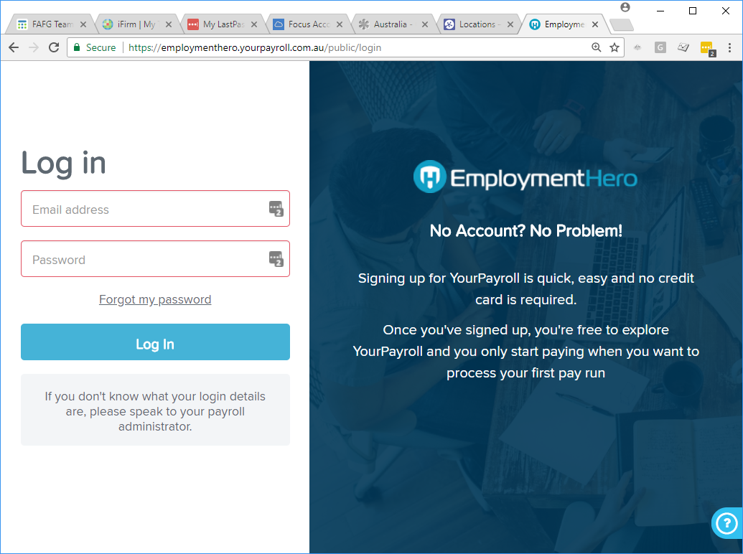
2. Type in your email address
3. Type in your password
4. Click ‘Log in’ button

On the first login, Users will need to agree to the Employment Hero Terms & Conditions before they can go any further. After accepting these terms and conditions, employees see their Dashboard.

**IMPORTANT**: If you are following these instructions you should not be prompted to enter information about your business. If the system asks you to enter that information, please log out and clear the caching in your web browser, shut down your web browser, reopen and re-login to the site. If it is then still asking you to complete the information please advise [cap@careertraining.edu.au](mailto:cap@careertraining.edu.au).

# PORTAL ACCESS & LOGIN – EXISTING SUPERVISORS

Persons who have approved CTI work placement timesheets via Employment Hero in previous years will not receive a new login email from Employment Hero, they are to continue with the same login details.

If the password has been forgotten this can be reset by going to <https://employmenthero.yourpayroll.com.au/Account/RecoverPassword>.

### To login:

1. Navigate to login page at: <https://employmenthero.yourpayroll.com.au>
2. Type in your email address
3. Type in your password
4. Click ‘Log in’ button
5. You will see a new landing page each time you log in asking you to choose which record you want to work with.

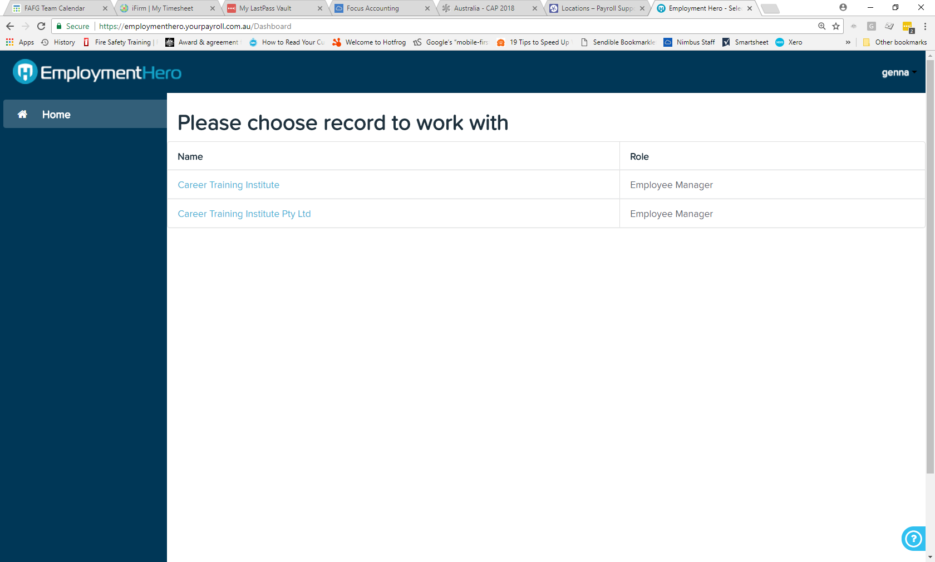

1. Click on the Career Training Institute Pty Ltd option to approve timesheets for 2020 enrolments. You will then be taken to the dashboard as normal.

# APPROVING TIMESHEETS

This is the responsibility of the Employer Manager / Supervisor and must be completed by the 8th of the month (following work completed).

On the Dashboard screen, Managers / Supervisors will see a count of any timesheets that have been submitted for their approval.



If there are timesheets awaiting approval then:

1. Click on the ‘Approve Timesheets’ button to open up the timesheets for review.



1. Click on the blue ‘Show timesheets for period’ text.

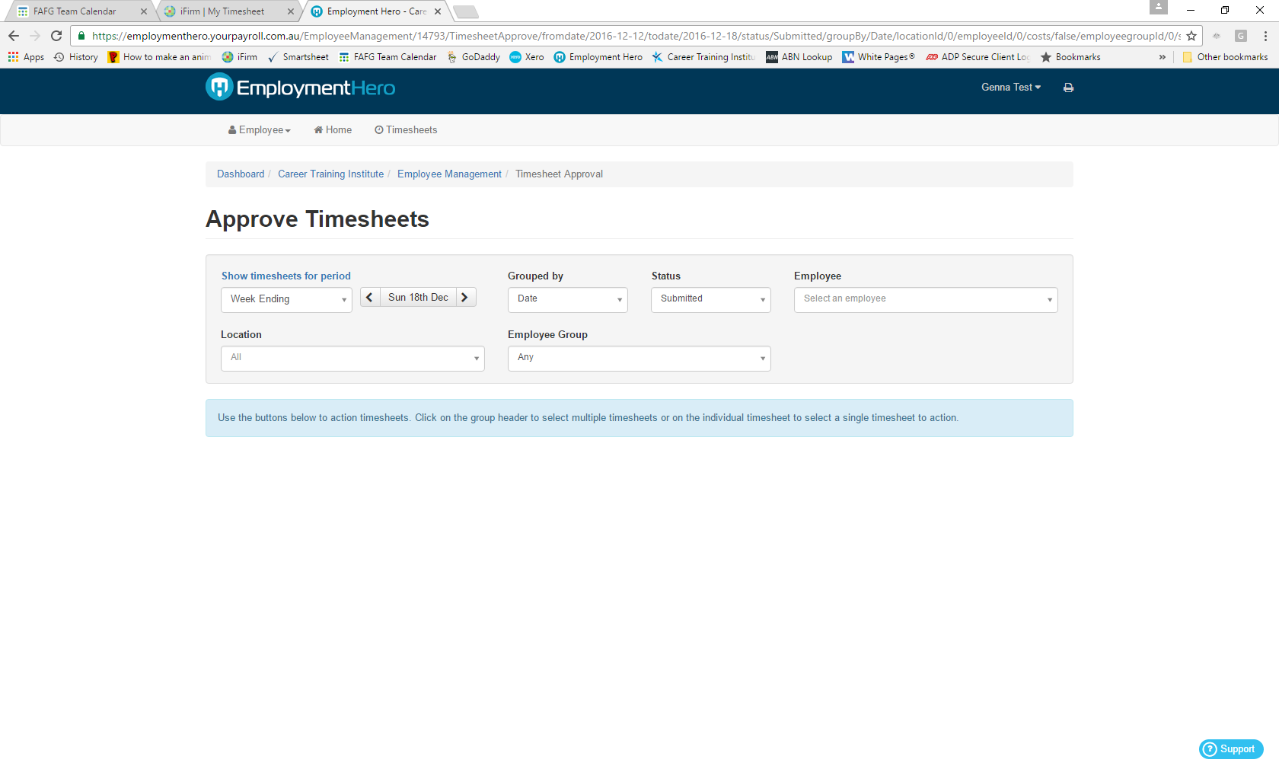

This will change the view options so you can set a date range.

1. Click into the date range field and then select the ‘Custom Range’ option from the dropdown list.

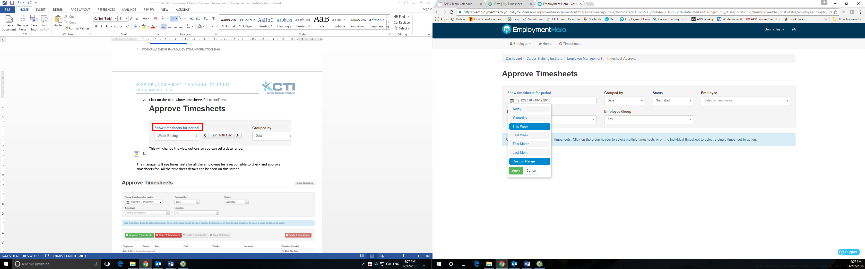

1. Calenders will show to the side which you use to select the custom date range. Enter the start date for the period as January 1 in the year you are approving timesheets for, then the end date for the period as todays date and then click on the green ‘Apply’ button.

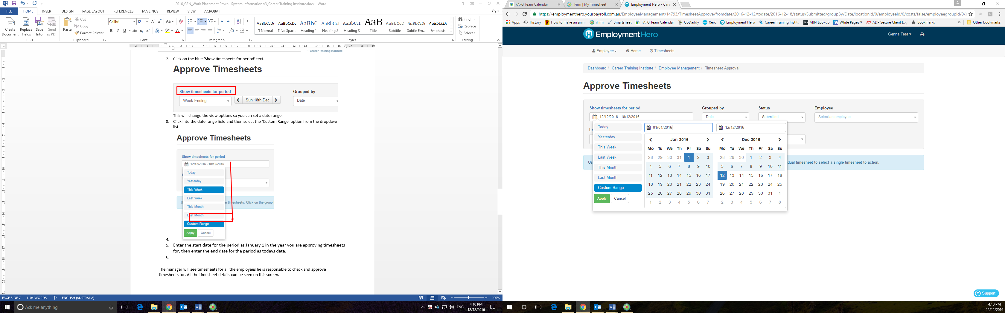

Enter the start date as the 1st date of the year the work was completed in

Enter the end date as today’s date

1. The manager will see timesheets for all the employees he is responsible to check and approve timesheets for. All the timesheet details can be seen on this screen.



1. To verify the timesheets:

* Select the ‘Approve’ button if you are happy with all timesheets as listed; or
* Select the ‘Reject’ button if you don’t agree with any of the listed timesheets; or
* You can click on each timesheet row to change the selection (those selected will then be highlighted in blue) then click ‘Approve’ or ‘Reject’ as relevant if you are only happy with some timesheets.

1. Changes are saved automatically, so the manager just needs to log out after approving / rejecting timesheets.

We then know that the student is completing the expected work placement.

# TIMESHEET NOTIFICATION SETUP

Employer Managers / Supervisors can set up a notification in the system so they are prompted when a timesheet has been submitted that they need to approve.

On the Dashboard screen, click on the blue ‘Manage Notifications’ button.

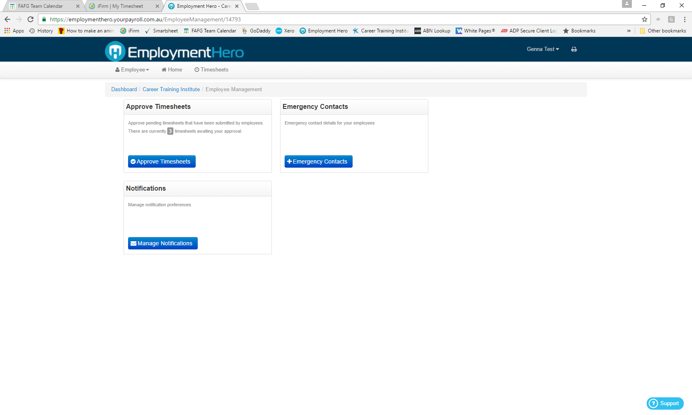

In the ‘My Notifications’ page that comes up:

1. In the ‘Select a business’ field enter ‘Career Training Institute’
2. Make sure the ‘Send me a daily reminder email’ box is ticked
3. Us the drop down box to choose whether you want to receive reminder emails each weekday or on selected days, if selected days tick the relevant days below the field
4. Enter the time you want to receive the email on the day/s you have selected
5. Make sure the ‘Include pending timesheets’ box is ticked
6. Click ‘Save’

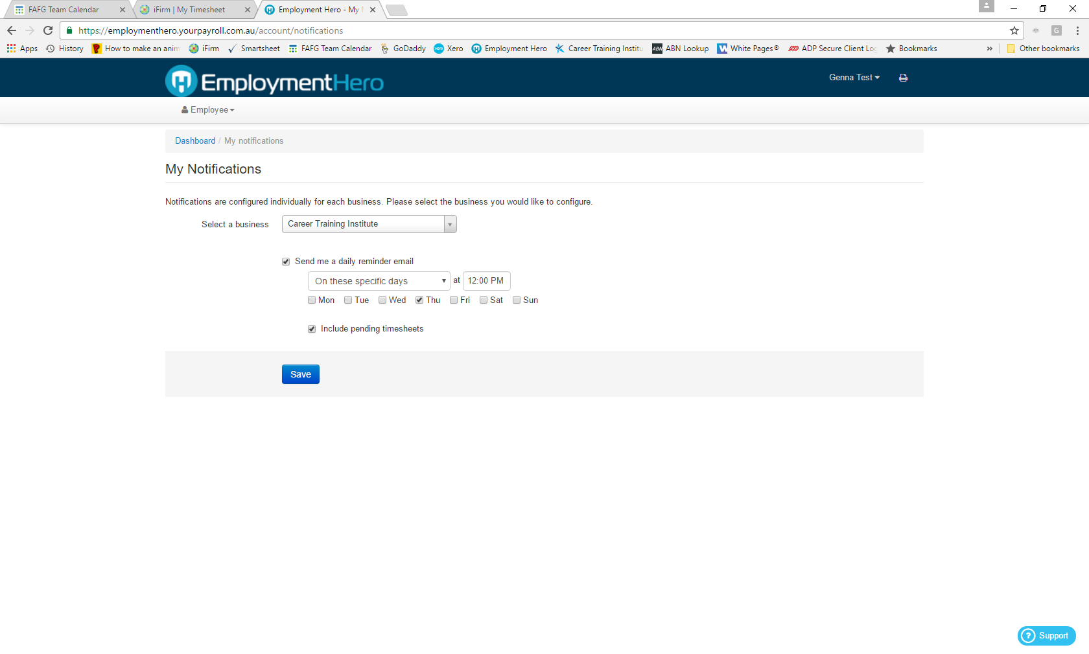

The supervisor should then receive an email on the selected day/s at the set time when there are timesheets awaiting their approval.